Arrays Utility Exercises

1. Write a method to generate an array of random integers. The method should accept 3 parameters: the number of elements, the minimum value and the maximum value.
2. Write a method that will allow a user to print an array of integers to the screen.
3. Write a method which accepts three parameters, an array of integers and two ints x and y which swaps the element at position x with the element at position y.
4. Write a method that accepts an array of integers and reverses the contents of the array.
5. Write a method that accepts two arrays of integers and merges their contents into a single array. All of the elements in array 1 should be first followed by all of the elements in array 2.
6. Write a method that accepts an array of integers and an integer value and returns the position of the integer in the array. The function should return -1 if the value is not present.
7. Write a method, interleave, which accepts two arrays of integers and merges them into a single array such that the first element comes from array 1, the second element comes from array 2, the third element comes from array 1 etc. (Consider how to handle arrays of different lengths)
8. Write a method that will allow a user to insert a value into an existing array at a given position. Call your method insert and it should take 3 parameters, the array, the position to insert it and the value to insert. (You may assume there is space in the array for the new element)
9. Write a method remove which will remove an element from an array and shift all subsequent elements back by 1. The final value in the array should be reset to 0.

Sample Output

**Question 2**

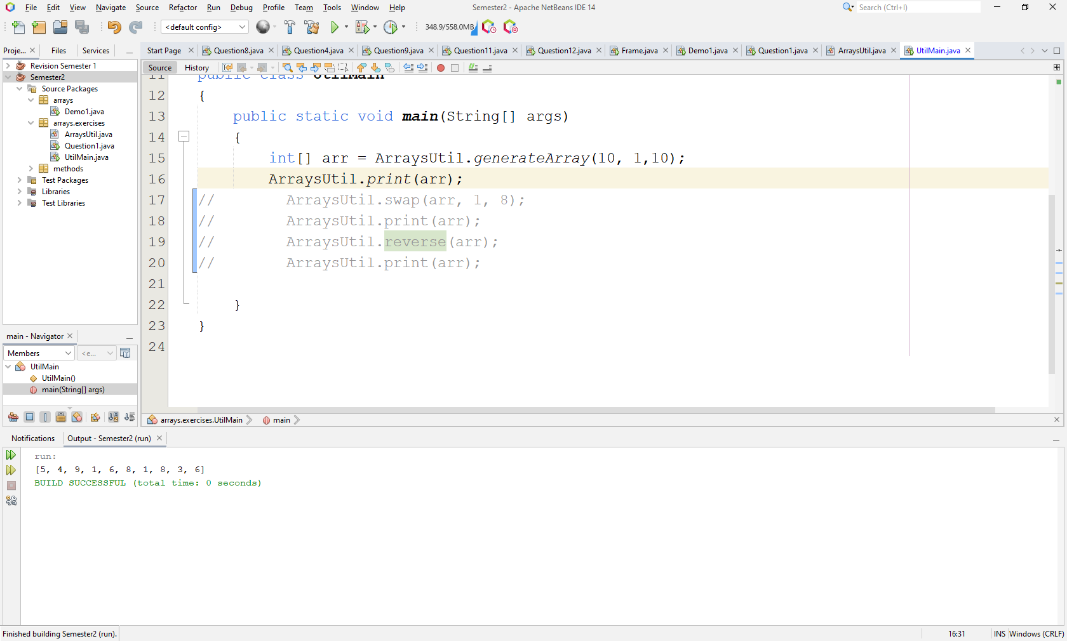

**Question 3: - (After swapping elements 1 and 8)**

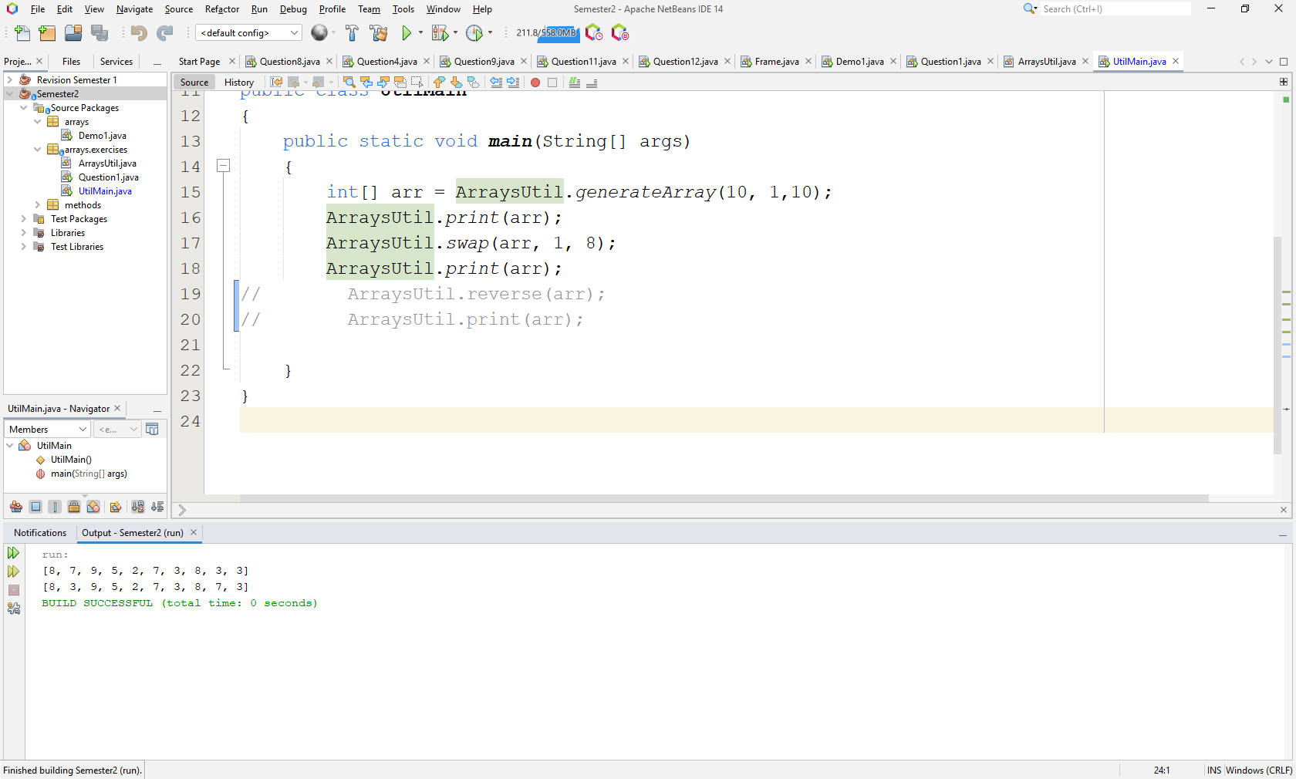

**Question 4:**

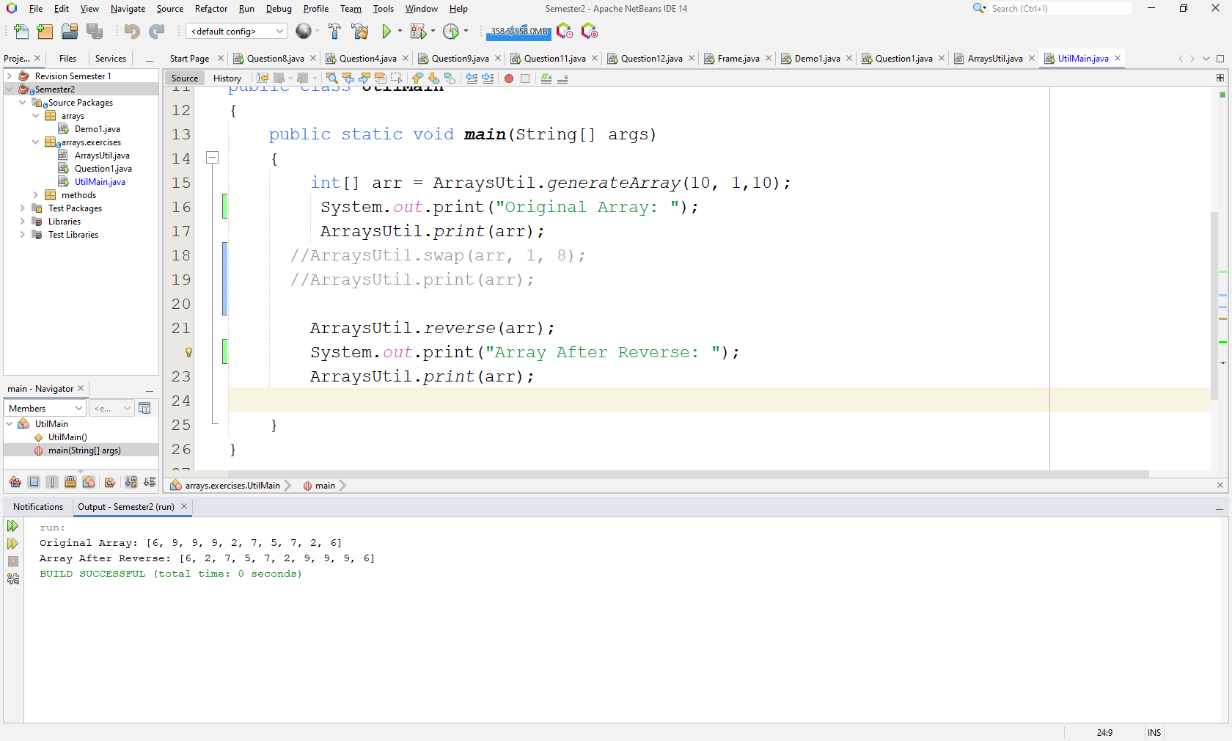

**Question 5:**

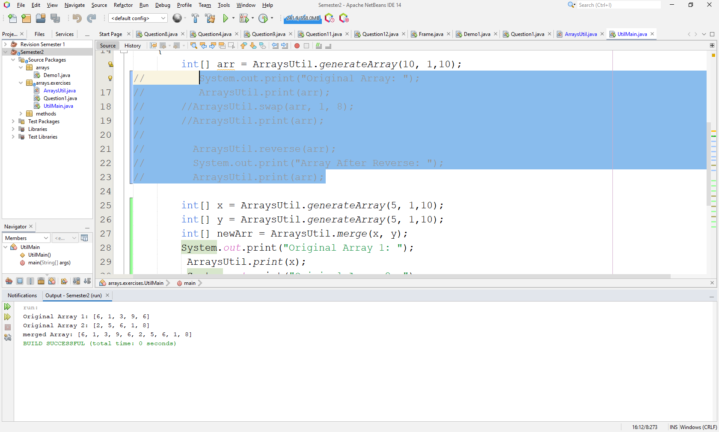

**Question 6:**

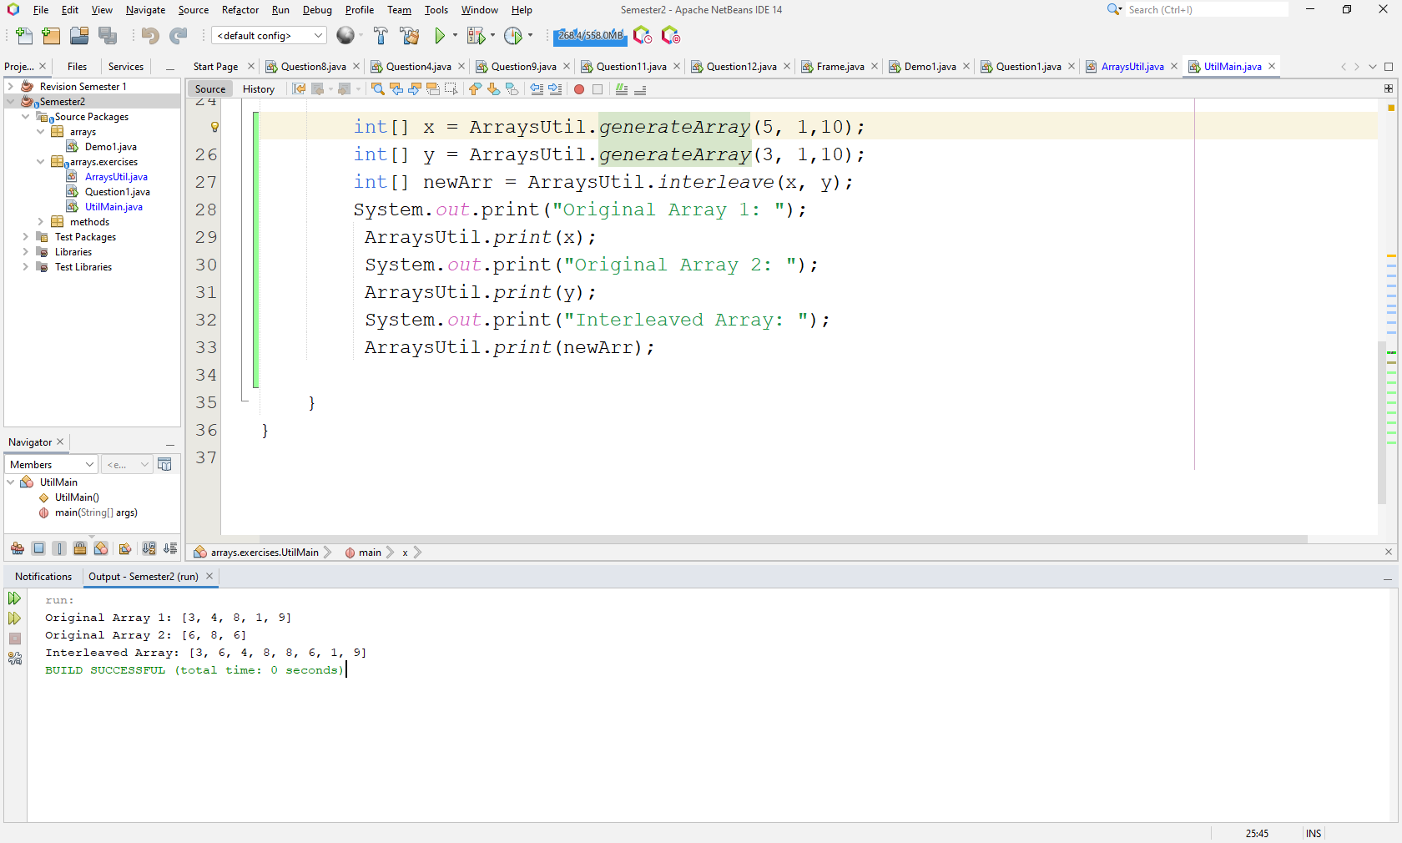

**Question 7:**

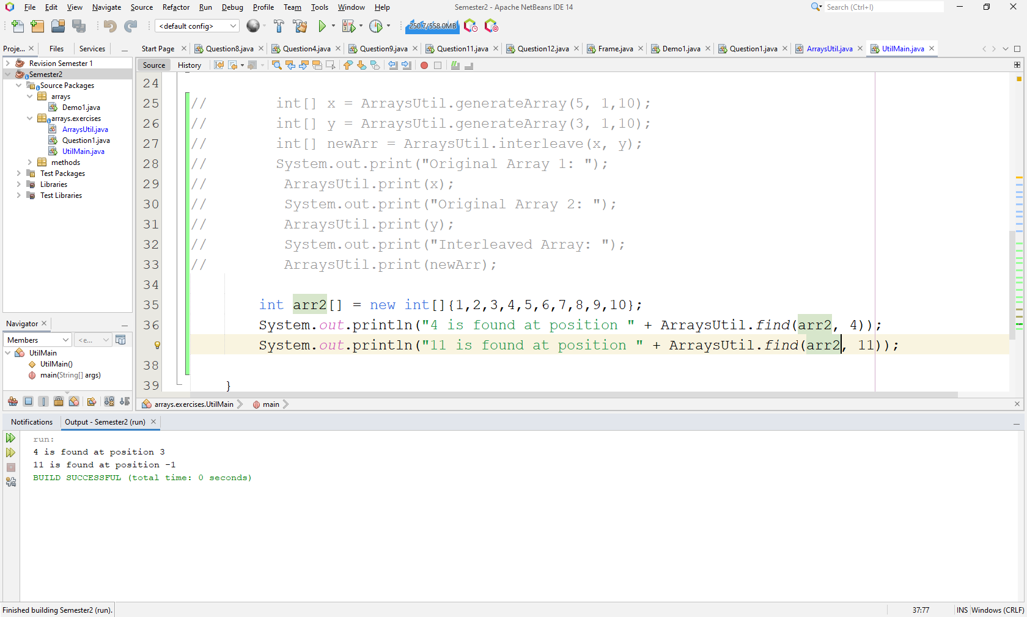

**Question 8: - After insert 12 at position 3**

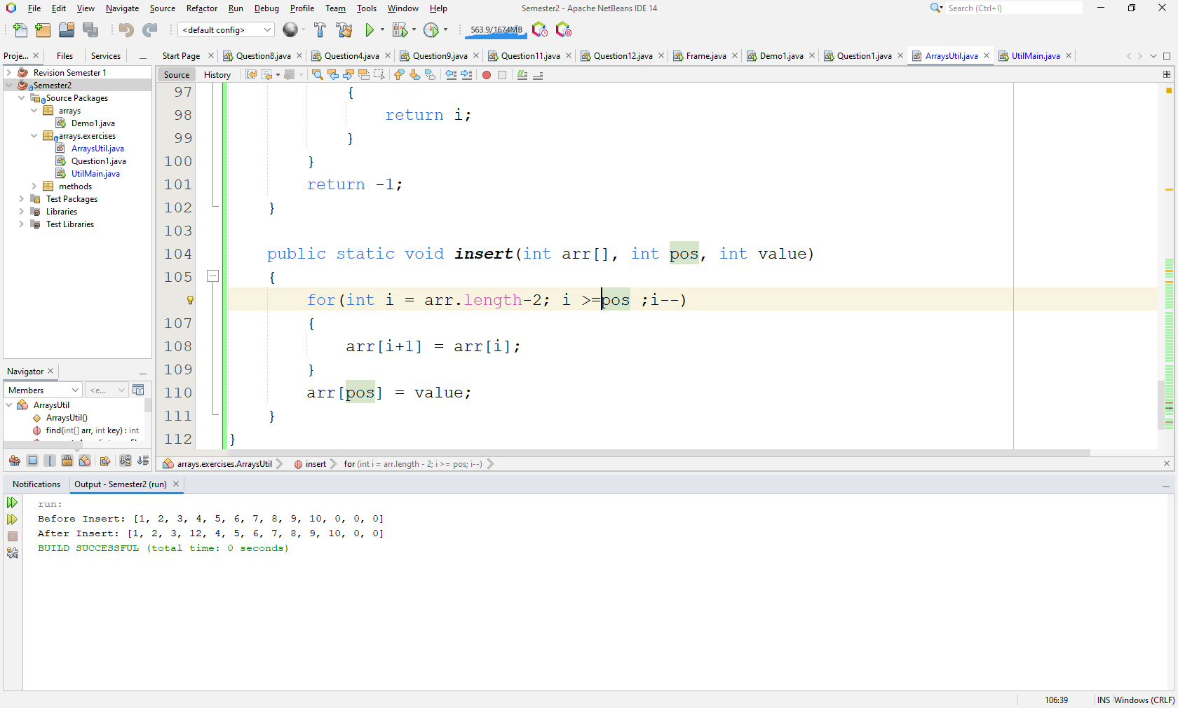

**Question 9: - After removing element 3**

